Tim Bui:

Two football teams battle for possession of the ball on a pitch of green grass. Other players lounge against cotton candy coloured cement walls that could surround a children’s playground. However a closer look reveals the concertina wire topping the walls and guards keep watch on the action below. The inmates in Tangerang Correctional Facility outside Jakarta, don’t have much in common besides long prison sentences, lives of poverty and daily violence. However, today, the international NGO, Search for Common Ground has arrived with a few tools to help change things. These wil enable the prisoners to manage the anger that sent them here in the first place. One of the tools is football, the other is a TV series called Tim Bui.

Before playing football today, the inmates viewed Tim Bui, a drama series set in a prison very much like the one they call home. The purpose of the screenings is not solely to entertain, but to use this series as a catalyst to mitigate violent behaviour through discussion.

Of the series, prisoner Saiful Bahri said: “The closeness between Agung (the main character) and prisoners brought changes into the prison. So if we want change, we’d better improve our relations.”

The idea is simple. A woman warden is appointed to head up a particularly violent prison where Javanese and Batak gangs fight to dominate the prison. Old attitudes are challenged when she insists that the prison guards treat the inmates with respect. That respect is as self-perpetuating as violence is anathema to guards who benefit from the brutality. However, Agung, the one guard who believes in her vision, manages to overcome the ethnic rivalry to organize a winning team.

The discussions about the show are lively and thoughtful. Inmate Sujanto Yusuf, comments, “We are living among different people. How can we unite and work as a team? Find the common thing.”
His fellow inmates seem to agree. As they watch the series, fixated, all of a sudden laughter breaks out during a scene in which one gang leader snarls at a rival who refuses to share a cigarette. Though insignificant to the story’s plotline, the realism of the scene resonates strongly with the inmates.

The Tim Bui prison screenings held at Tangerang are only a part of the mobile cinema/facilitated dialogue project for the show. At least 4 other prisons are involved in the program as well as 10 pesantrens (Islamic boarding schools). Each of the programs stress the need for tolerance and discussion in order to problem solve. Tim Bui is one of the methods used by SFCG to counter violence and even anti-terrorism in prisons, tools, which prison authorities have heartily embraced.

The interest in the series did not stop with the screenings or the football games. Many former prisoners engage with the Tim Bui Facebook page. One wrote: “Tim Bui tells a story about the complexity of life’s problems frequently faced in the real world, whether within or outside jail. (The messages I took out of Tim Bui are ones of) humanity, gender equality, the beauty of peace, tolerance, team work, and caring for one another.”

The Tim Bui website has been a popular tool to keep the discussion about the series in the public eye. After each show is broadcast, viewers Tweet or blog about the topics presented in the series. A YouTube page is set up so viewers can watch re-runs.

SFCG partnered with Indonesia’s SET Film to produce the series and the national television station Metro TV to broadcast it. Funding was provided by UKAID’s Governance and Transparency Fund. (GTF)

Caption: From Tim Bui. “Agung” played by Agus Kuncoro (Center) counsels rival gang leaders.
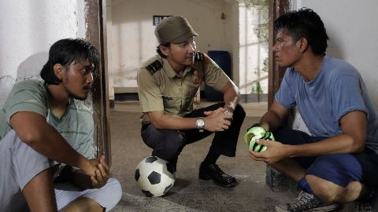

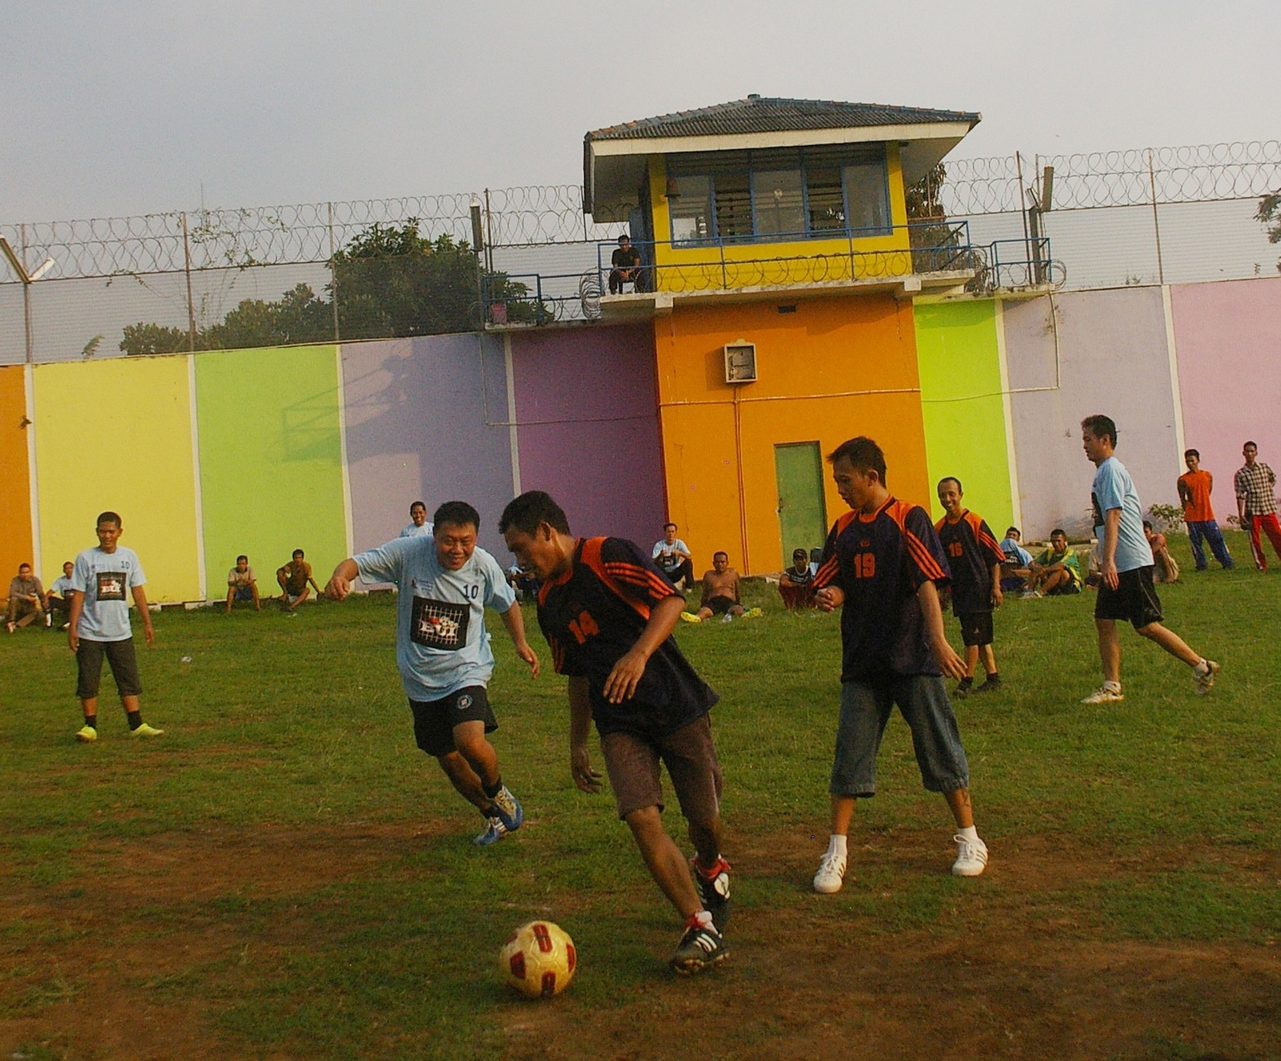

Inmates at Tangerang Prison play football following screenings of Tim Bui.

